
JIM JUNIOR SCHOOL - KIBUKU
“To Excel Is Our Aim”
Tel (+256)787643047 or (+256)756072716
Email: schooljimjunior@gmail.com

END OF TERM ONE EXAMINATIONS 2023
PRIMARY ONE
MATHEMATICS
DURATION: 2HRS 30 MIN
Name ____________________________________________________
 | Add  - 2 + 2 =  - 1 + 3 + 2 = |  |  | Fill in the missing numbers.  - 5, ______, 7, 8, _______, 10  - 0, ______, 2, _______
 | Takeaway.  - 8 – 2 =  - 5 – 3 = |  |  | Circle the smaller number.  - 2 and 6  - 11 and 5
 | Match correctly.  10 six  8 twenty  20 ten  6 eight |  |  | Name these shapes.
 | 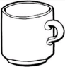  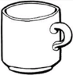  Count and write number.  = ____  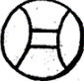  = ____  = ____  = ____ |  |  | Write the number before.  - _________, 8  - _________, 11
 | Shade for the given number.  = 2  = 1  = 4 |  |  | Write in words.  - 2 _________________________  - 10 _________________________
 | Count members in the sets.  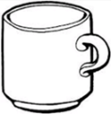  A set of ____________ books.  A set of _________________tins. |  |  | 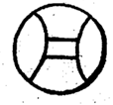  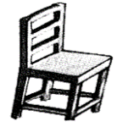  Form new sets.
 | - Four plus two equals ________________________  - Seven plus one equals.  _________________________ |  |  | Write the number after.  - 12, _________________  - 16, _________________
 | Circle the bigger number.  - 9, 2  - 10, 20 |  |  | - How many days make a week?  _____________________________________  - Fill in the missing letters.  - M_____nday  - Fr_____day
Arrange numbers from the smallest to the biggest.
- 5, 2, 3, 1, 0, 4
____________________________
- 10, 9, 7, 8
____________________________
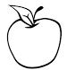
These children have apples.
Mary
Sam
Ali

- Ali has _________________ apples.
- Who has one apple?
___________________________________________
- Who has three apples?
___________________________________________
- How many apples do they have altogether?

Join the sets.

=
+

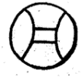
=
+

Match the same sets.
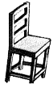

Use “bigger” or “smaller” to answer correctly.
A
B

- Chair B is ________________ than chair A.
- Chair A is ________________ than chair B.
 | Count and write beads.  - T O  - T O |  | Match correctly.  Square  rectangle  triangle  oval
 | How many months make a year?
END

